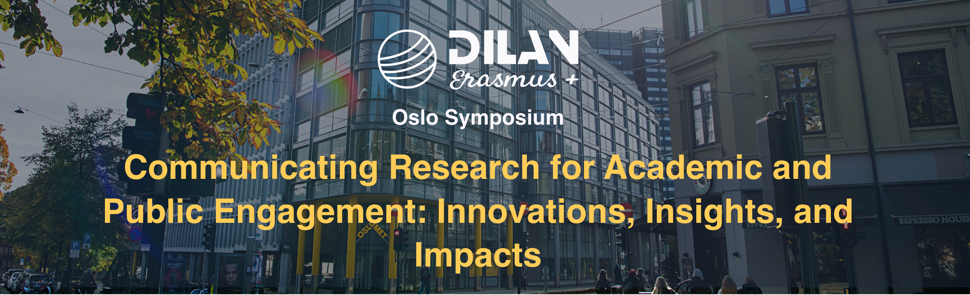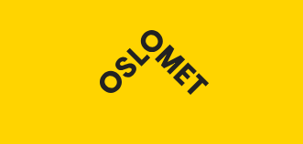

From Research to Reach:

Communicating Science Effectively on Social Media
Dr Julio Gimenez, University of Westminster
This hands-on workshop will help you explore practical models of science communication tailored for digital and social media. You will experiment with a number of strategies to communicate your research with clarity, creativity, and confidence.

1. Icebreaker: Memorable Science Post (10 mins)

Think of the last piece of science communication you saw on social media that stuck with you. Write down:

What platform it was on

What made it memorable

Why it worked (or didn’t)

2. Principles of Effective Science Communication: 3 Cs (Notes, 15 mins)
Clarity – use plain language, avoid jargon, use analogies
Creativity – visuals, storytelling, humour (but…)
Credibility – accuracy, referencing, transparency
Further readings:
Gimenez, J., Baldwin, M., Breen, P., Green, J., Gutierrez, E., Paterson, R., Pearson, J., Percy, M., Specht, D. & Waddell, G. (2020). Reproduced, reinterpreted, lost: Trajectories of scientific knowledge across contexts. Text & Talk, 40, 3, 293-324. https://doi.org/10.1515/text-2020-2059
Sedgwick, C., Belmonte, L., Margolis, A., Osborn Shafer, P., Pitterle, J., & Gidal, B. E. (2021). Extending the reach of science – Talk in plain language, Epilepsy & Behavior Reports, 16, 100493, https://doi.org/10.1016/j.ebr.2021.100493

3. Strategies (10 mins)

One useful way of planning your science communication online is to start by
- Reflecting on your aims, audience, platform and audience engagement
- Exploring the different Possibilities you have for each of the aspects you reflected upon
- Researching further details of such aspects, and
- Thinking how you will Measure the impact of your communication.

This is called the “RPRM Strategy”.

3.1 The RPRM Strategy

REFLECTION, POSSIBILITIES, RESEARCH, MEASURE

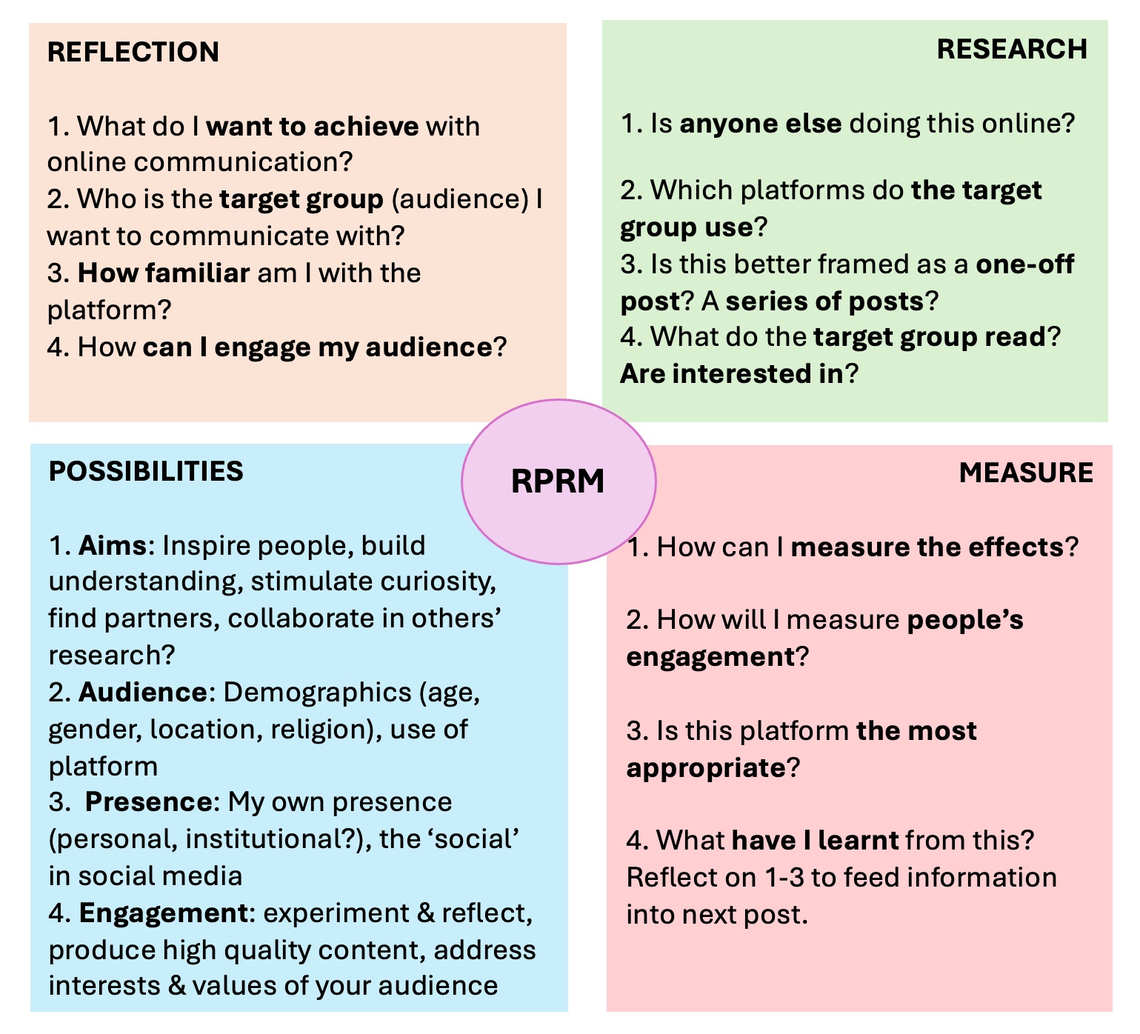
Further reading:
National Co-ordinating Centre for Public Engagement (website): https://www.publicengagement.ac.uk/

3.2 RPRM and Platforms: Exercises

a) Twitter / X – Storytelling Threads
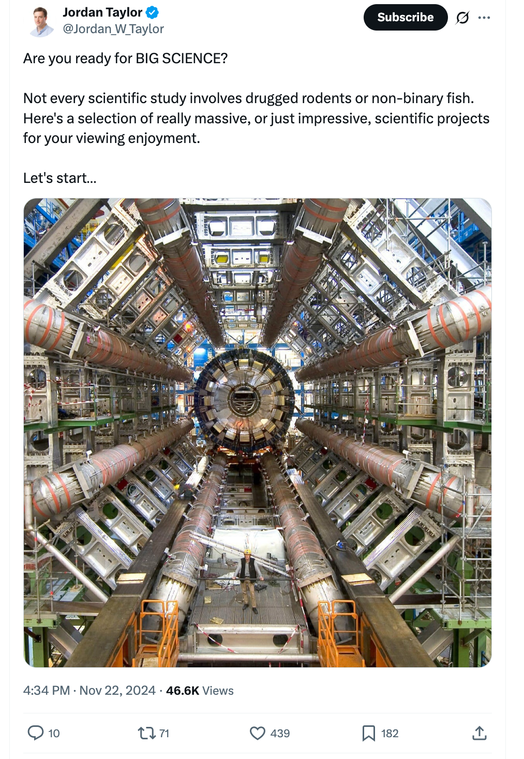
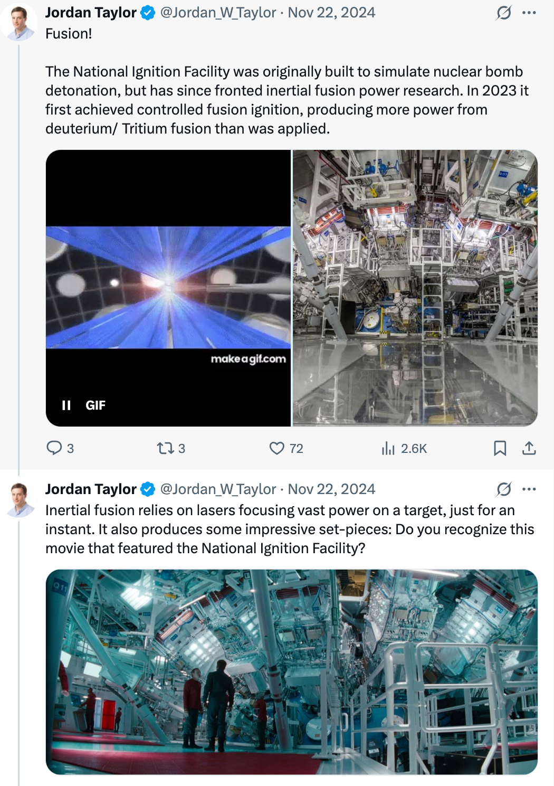
1. RPRM Strategy?
2. How was the thread created?
3. Why it worked (or didn’t)?

Your task: Draft a 3–5 tweet thread introducing your research.
________________________

b) Instagram – Visual Storytelling
https://www.instagram.com/p/DNif9QkI81s/
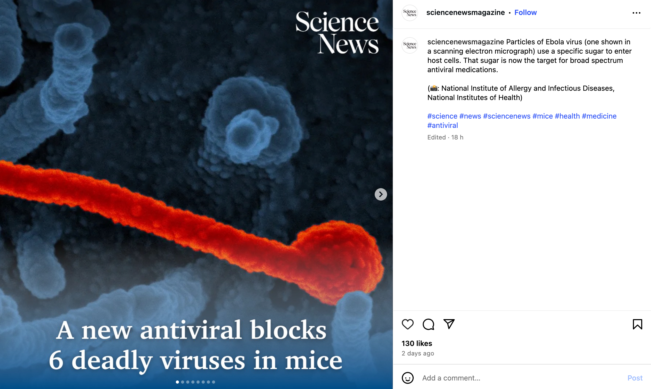
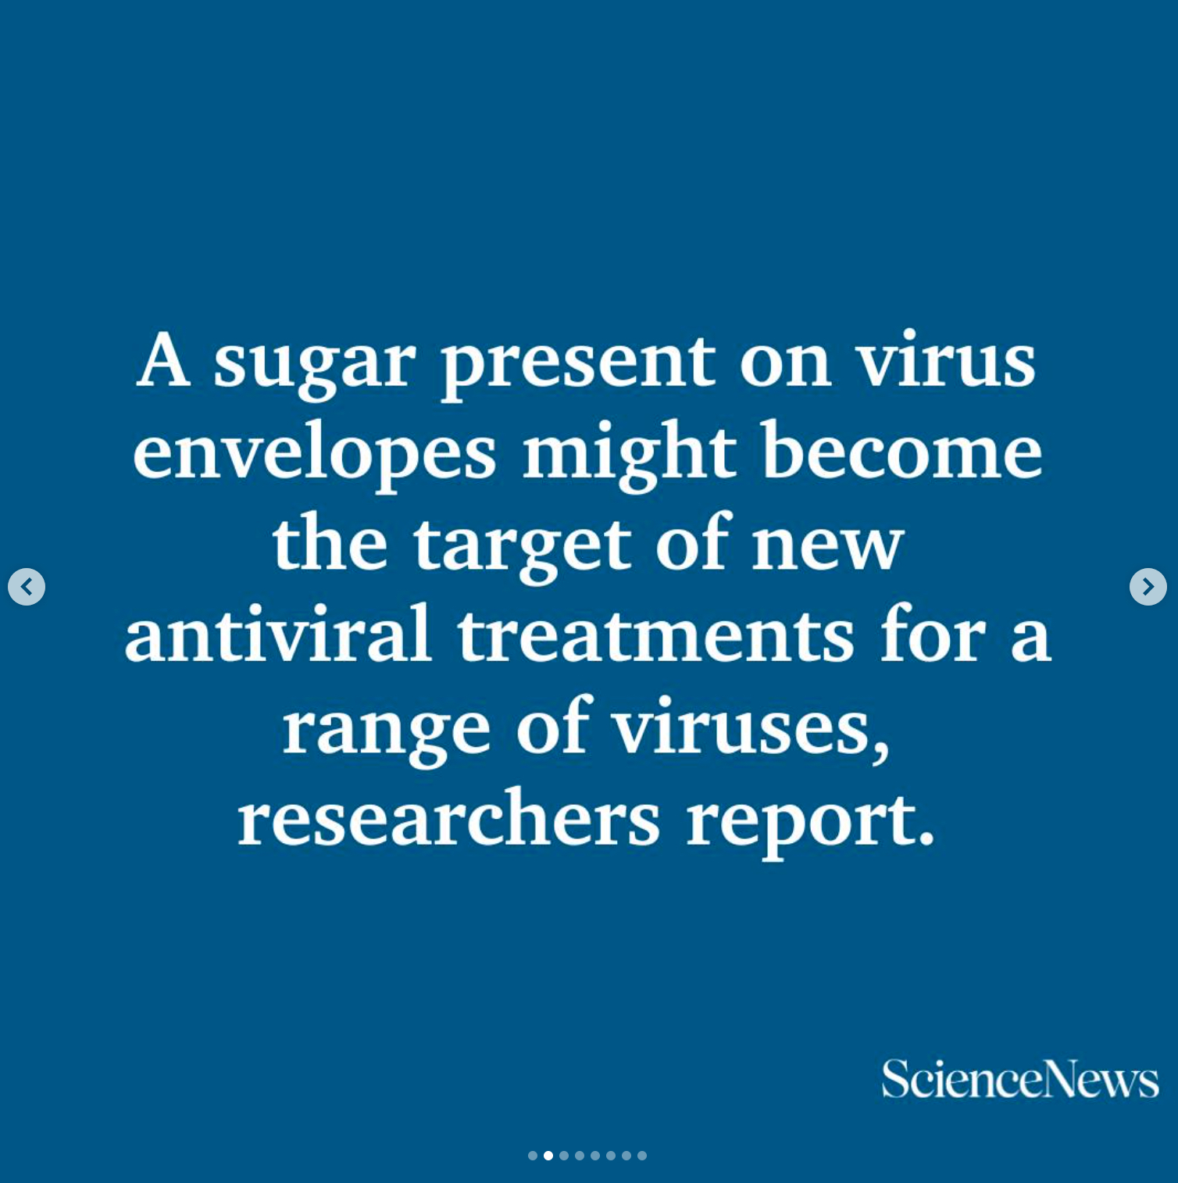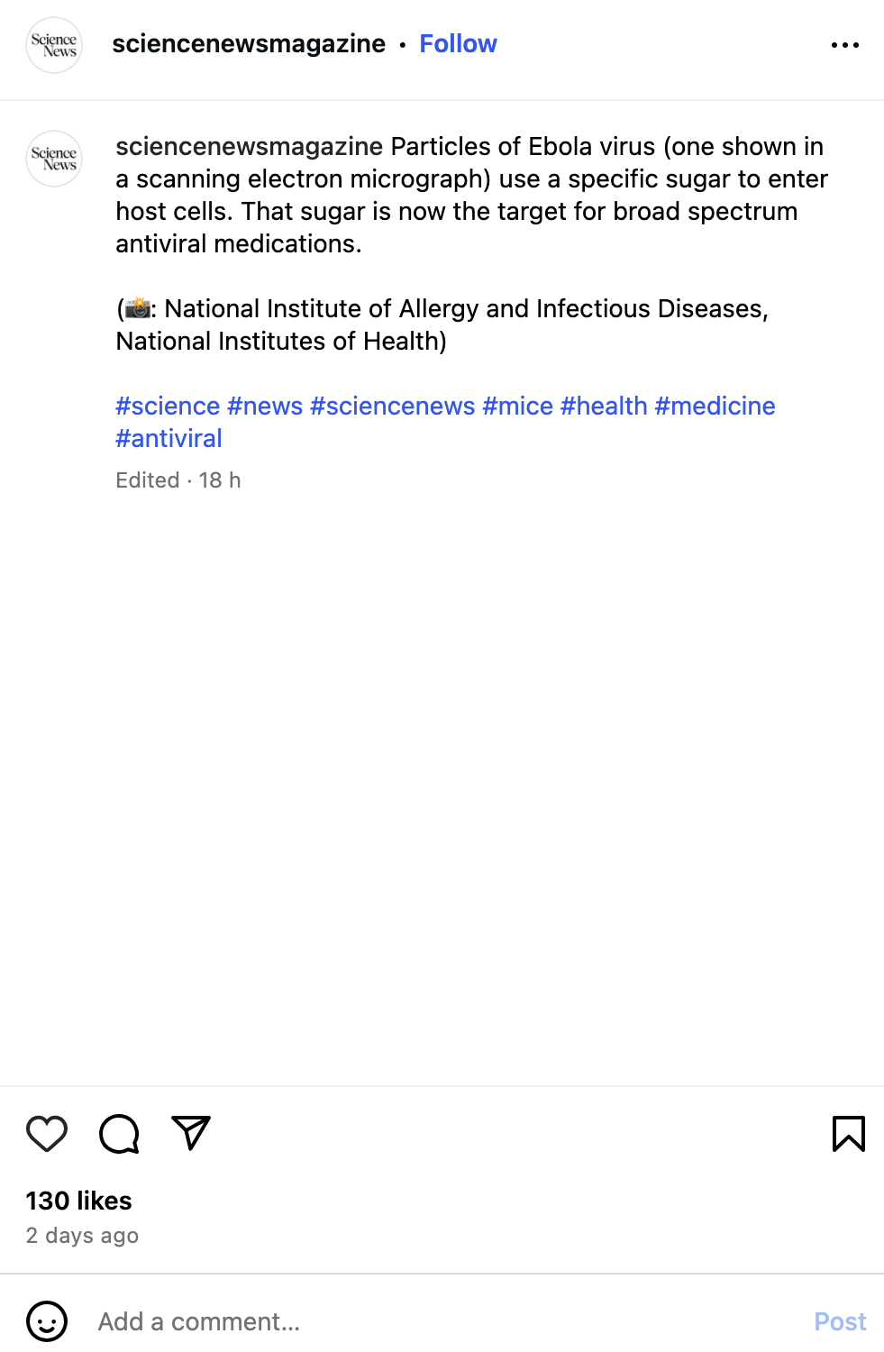

1. RPRM Strategy?
2. How was the narrative created?
3. Why it worked (or didn’t)?

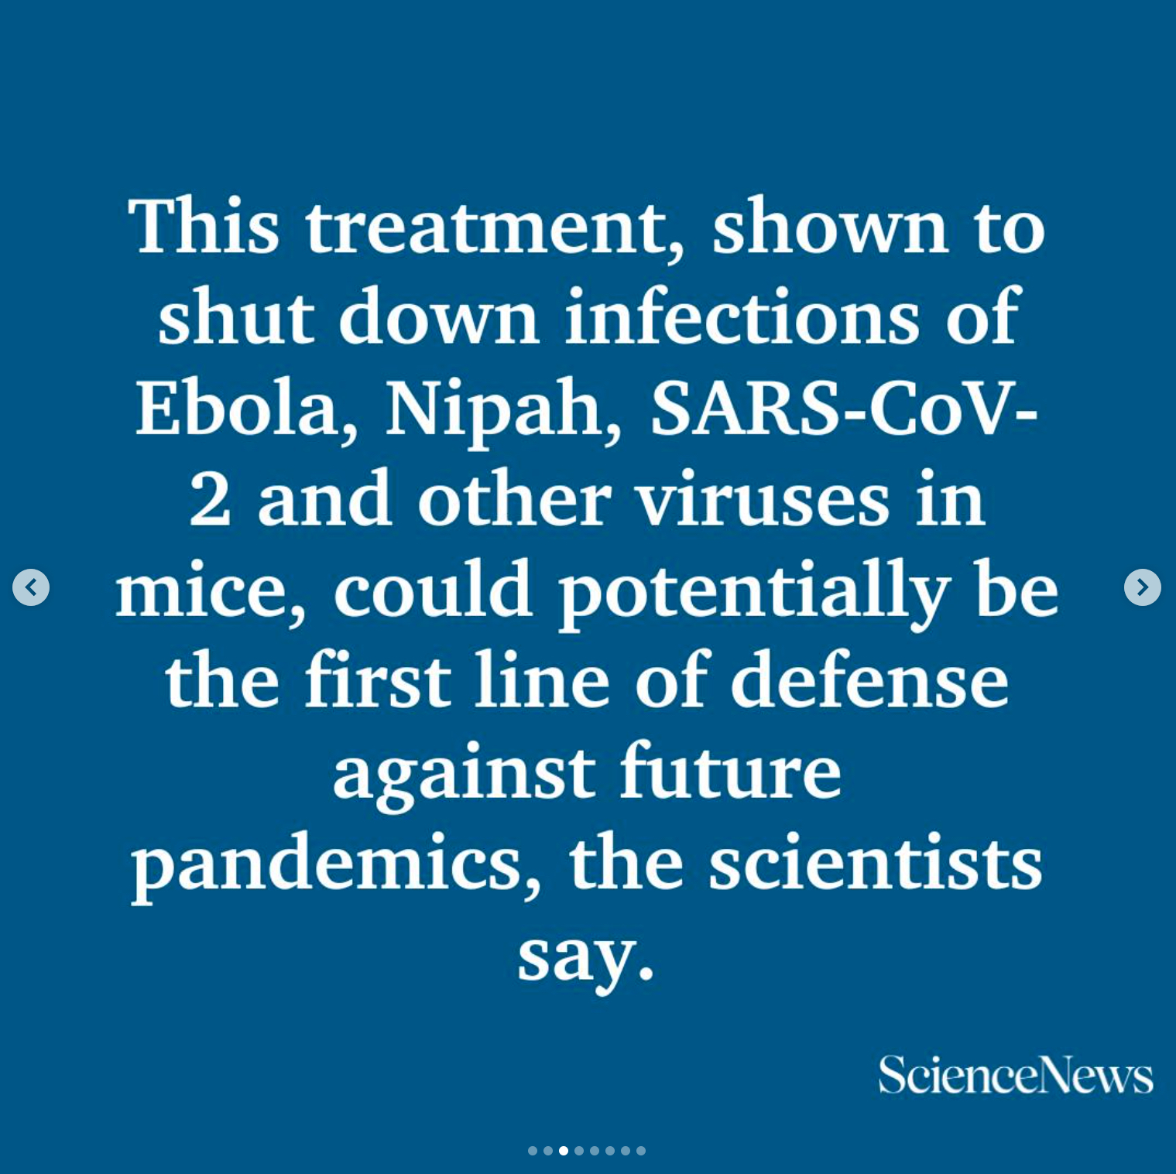

Your task: Draft a 3-slide carousel OR a caption + image idea for your research.
________________________

c) LinkedIn – Professional Narratives
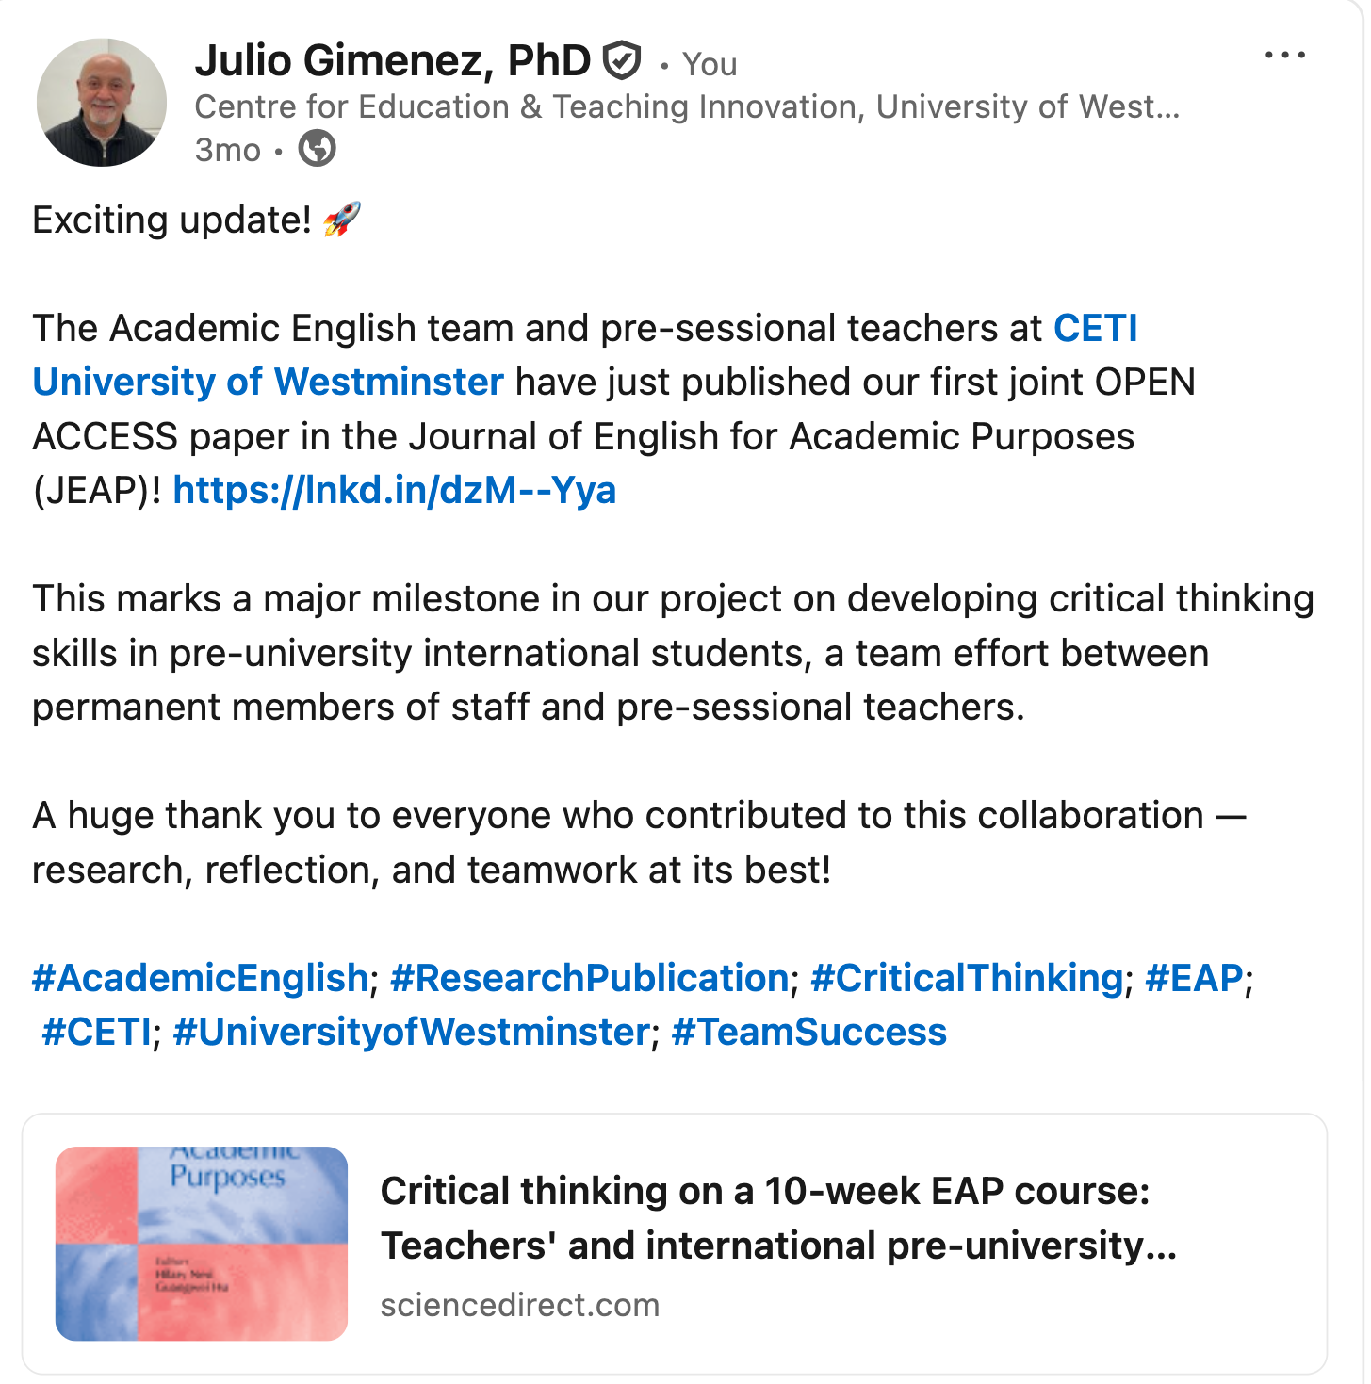
1. RPRM Strategy?
2. How was the narrative created?
3. Why it worked (or didn’t)?

Apologies for the plug!

Your task: Draft a LinkedIn-style post highlighting your research impact.
______________________
Wrapping up
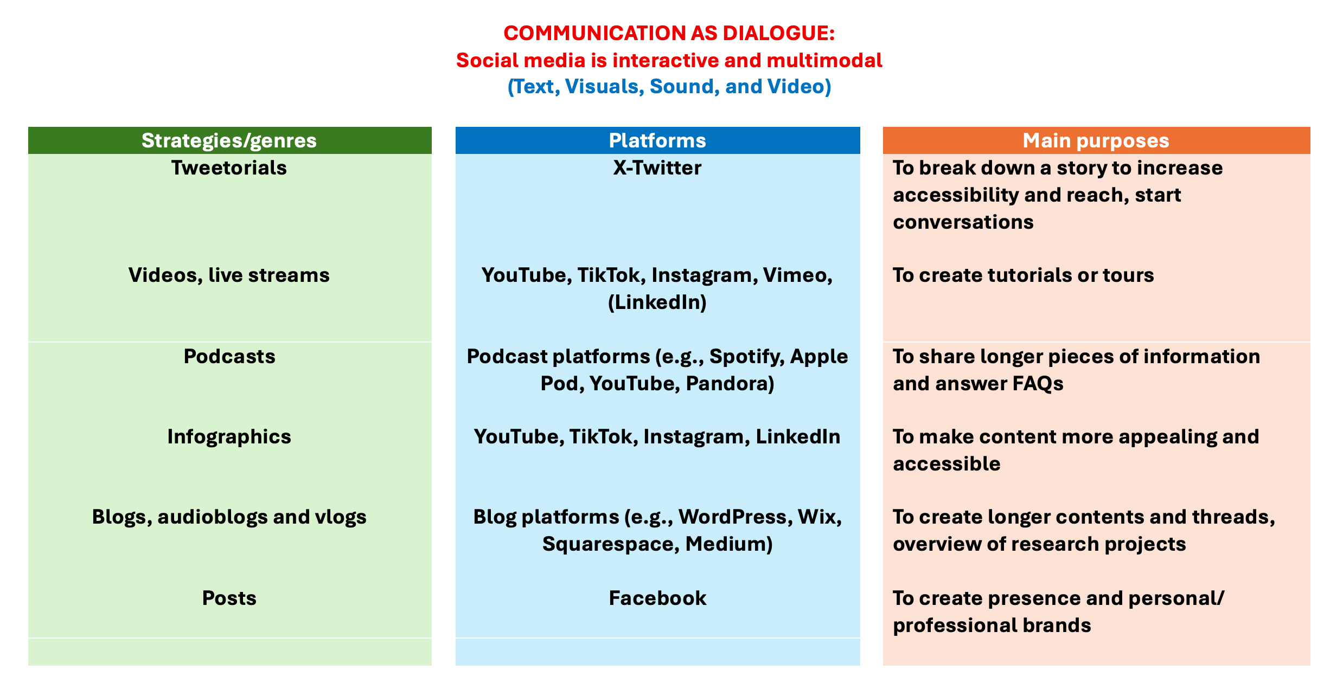

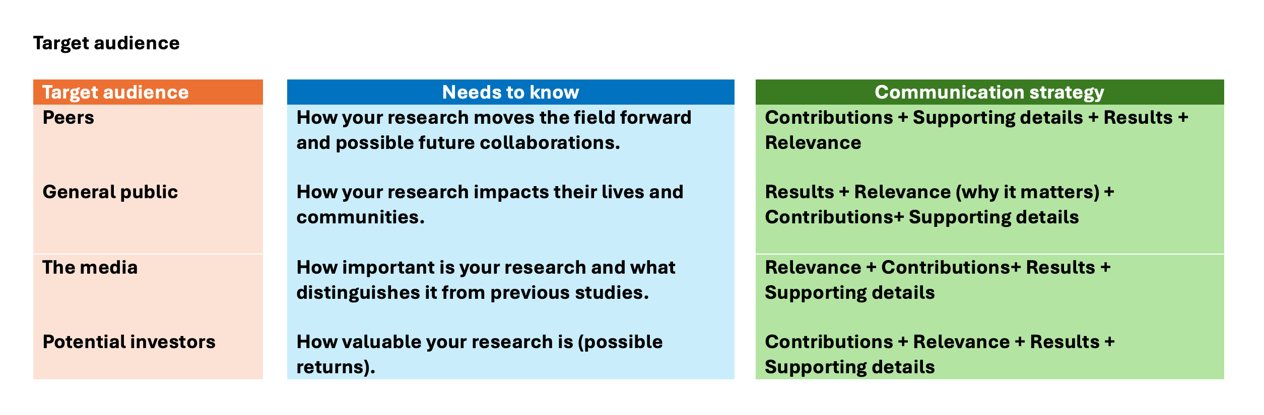

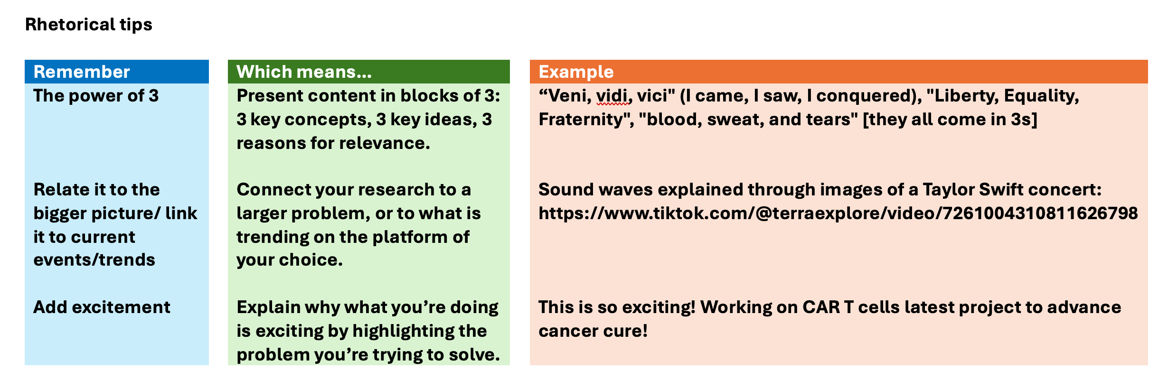

4. Critical Reflection (Discussion) (10 mins)

Discuss with your group:
• What worked well on each platform?

• What challenges or risks do you see?

• Which platform feels most natural for your research?

• How can AI enhance your communication strategy?

5. Final Task: Your Research Post (15 mins)
Pick one platform and draft a complete post about your research. Think about:
- Plain language
- Tone and audience
- Images, analogies, storytelling
- Hashtags or links
Draft here:

________________________

Wrap-Up and Takeaways
- Key reminders: The 3 Cs (Clarity, Creativity, Credibility), the AAPE strategy
- Different platforms have different requirements, and these make them suitable for particular posts
- My next step for communicating my research online involves….
“Nothing in science has any value to society if it is not communicated, and scientists are beginning to learn their social obligations.” Anne Roe Simpson (American clinical psychologist- 1904-1991)

